1. Check the DATE on computer (can’t be too far off)
2. Make sure the QuizMachine version is at least 3.1.x, but 4.1.q49 is better and must be used for Windows 7 and a USB interface box.
3. Load QM file using the scoresheet function/”Import Names/Schedules” and that the “Use Imported Names” box is checked.

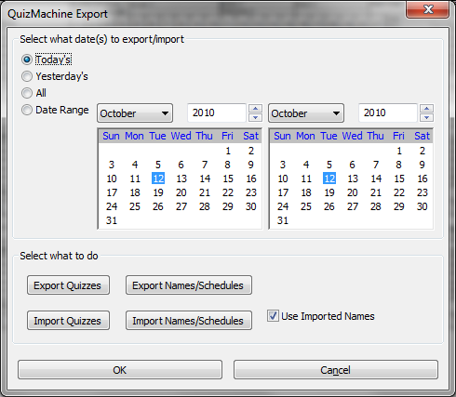

**CHECK QM Options** (either from Lineups or Setup)

Rules/Method: Tournament (Critical)

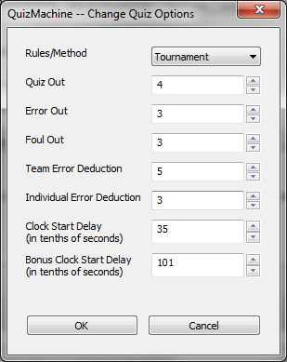Parameters:

Quiz Out = 4

Error Out = 3

Foul Out = 3

Team Error Deduction = 5

Individual Error Deduction = 3

Clocks = leave as is

(the picture below is the default)

**ENTER QM “Create a New Quiz” OPTIONS** (from Lineups)

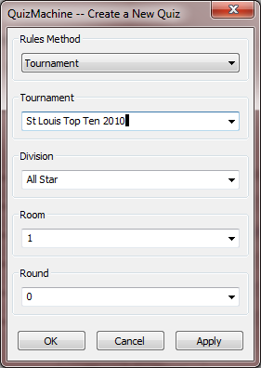

Rules Method = Tournament

Tournament = St Louis Top Ten 2010

Division = All Star

Room = 1 (just the room number from 1-18)

Round = 0 (zero)

Click OK

A message indicating that the previous round was not complete will be displayed. Click OK.

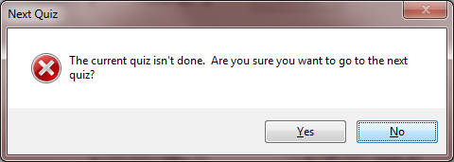

**AT THE LINEUPS SCREEN**, click next quiz. It should display Round 1 and you should be able to drop down team members. Check the schedule to make sure the right teams are in this room.

**IF USING A CONNECTION TO THE SERVER (either wired or wireless) follow this procedure:**

From the QuizMachine Properties window, select Server/Sneakernet; make these entries:

1. Make sure the “Use Imported Names” box is checked.
2. Enter the IP address of the server (do an ipconfig /all at a command prompt on the server to obtain the server IP address). The network must use DHCP or manual IP addresses will need to be entered on all client QuizMachine computers.
3. Tournament key is not required.
4. Physical Bldg/Room should be the same as the room # in “Create a new Quiz” above.
5. Make sure the “Use the Server:” check box is checked.
6. Click the “Check in with the Server” button to verify access to the server.  
   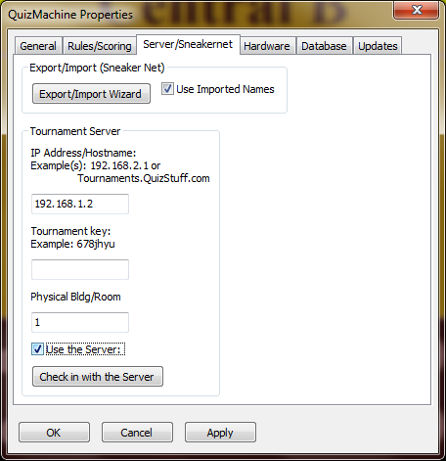

Common errors or oversights:

1. The room or round number or Tournament or Division does not match what is in the QuizMachine schedule file. This will generate the following error:

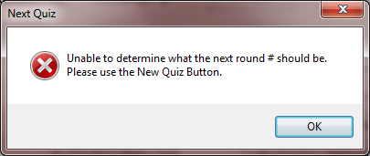

1. Not loading the schedule file before clicking OK at round 0. Same error is displayed.

This room setup should be complete.